HW4.3 Centroids of More Complex Shapes
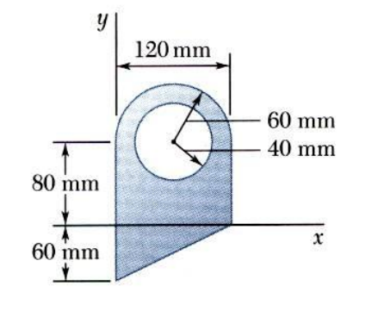
Find the centroid (x̄, ȳ) of the composite shape shown.

Step 1: Identify Shapes
Positive areas:
1. Rectangle
2. Semicircle
3. Triangle
4. Circular hole (Negative area)

Step 2: Calculate the Area of each shape.

Shape 1: ________________________
Shape 2: ________________________
Shape 3: ________________________
Shape 4: ________________________

Step 3: Calculate the x̄ (x Centroid) of each shape.

Shape 1: ________________________
Shape 2: ________________________
Shape 3: ________________________
Shape 4: ________________________

Step 4: Calculate the ȳ (y Centroid) of each shape.

Shape 1: ________________________
Shape 2: ________________________
Shape 3: ________________________
Shape 4: ________________________

Step 5: Calculate the A_{i}x̄ of each shape.

Shape 1: ________________________
Shape 2: ________________________
Shape 3: ________________________
Shape 4: ________________________

Step 6: Calculate the A_{i}ȳ of each shape.

Shape 1: ________________________
Shape 2: ________________________
Shape 3: ________________________
Shape 4: ________________________

Step 6: Totals

Total ΣA = _____________
Σ(Ax)=______________
Σ(Ay)=_______________

Step 7: Centroid Formulas
x̄ = Σ(Ax) / ΣA
ȳ = Σ(Ay) / ΣA

Final Answer
(x̄, ȳ) = (__________, __________)

Extension Question
Which part of the shape most affects the x-location of the centroid? Why?

